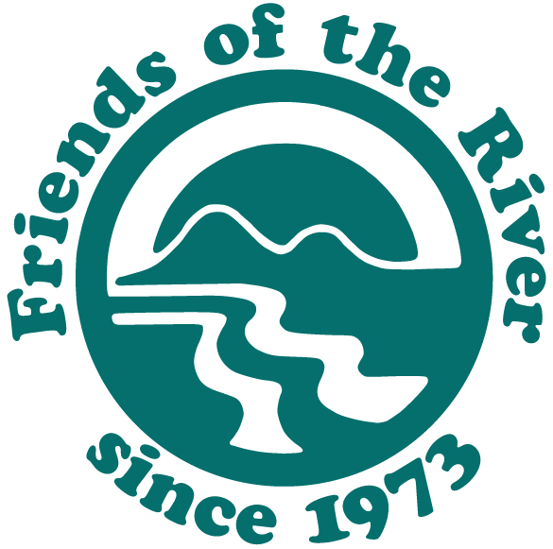
Proposed Sites Offstream Storage Reservoir
Real Facts & Issues – February 10, 2017

The Sites Offstream Reservoir Project is currently under study by the Sites Project Authority (a Joint Powers Authority or JPA made up of water districts and counties), California Department of Water Resources (DWR), and the U.S. Bureau of Reclamation (BOR). In late January 2017, the Sites JPA issued a Notice of Preparation (NOP) for a Sites Project Environmental Impact Report (EIR).

Until the Sites JPA releases a draft EIR and supporting documents for public review, much of the available information about Sites is found in DWR’s incomplete 2013 Preliminary Administrative Draft Environmental Impact Report (PADEIR). Without an up to date feasibility report and EIR, the project’s alleged benefits and actual cost are speculative.

The stated purpose for the Sites Reservoir is to increase water supplies to meet existing water contracts and provide greater flexibility in water management for agricultural, municipal, and environmental uses. Purported environmental benefits of the project may include increasing the survival of salmon and steelhead in the Sacramento River, increasing operational flexibility of other reservoirs (Trinity, Oroville, Folsom) for environmental purposes, providing water for wildlife refuges, and improving Delta water quality.

Conservation groups are concerned that proposed diversions from the Sacramento River to fill the Sites Reservoir may result in unacceptable impacts on the river’s riparian and aquatic ecosystems, fish and wildlife (many of which are threatened and endangered), and water quality. The reservoir itself will drown thousands of acres of grassland, oak woodland, and riparian habitat. In addition, much of the expense of building the multibillion-dollar project may be borne by taxpayers because government agencies intend to justify the project as allegedly providing water for environmental purposes, while the political push for the dam and reservoir comes from water districts who hope to benefit from the project by increasing their consumptive water supplies.

Project Description – The Sites Reservoir area is in the western Sacramento Valley, about 10 miles west of the small town of Maxwell and Interstate 5 in northern California. Two potential reservoir sizes evaluated in detail could store 1.27 million acre feet (MAF) and 1.81 MAF (in comparison, Folsom Reservoir on the American River stores about 1 MAF). The reservoir would require the construction of two large dams up to 310 feet-high and up to nine smaller saddle dams. Most of the water stored in Sites would be diverted from the Sacramento River using the existing Red Bluff Pumping Plant and Tehama-Colusa Canal, and the Glenn-Colusa Irrigation District diversion and canal. In addition, a new facility – the Delevan diversion and pipeline would be constructed on the river north of Colusa. Combined, the diversions will have the capacity to take as much as 6,000 cubic feet per second (CFS) of water from the Sacramento River.

Water Yield – Total storage volume is only indirectly related to water yield, which is the amount of controllable water a reservoir may make available for deliveries. The long-term average annual water supply provided by Sites to water contractors and refuges was modeled by DWR to range from 213 to 246 thousand-acre feet (TAF) a year, depending on the ultimate size of the reservoir and how the reservoir is operated. That’s as little as 0.5% of California’s total annual water use. Total average annual yield for all purposes is modeled to be 428 to 488 TAF per year. How this yield would actually be divided between meeting water contracts and hypothetical environmental improvements depends on the final project formulation and annual operations. DWR has projected one example that would allocate up to 246 TAF of water to urban and agricultural water agencies. About 16% of this amount would go to north of Delta water contractors and 54% to south of Delta water contractors. The rest would be allocated to provide Delta water quality and environmental benefits. The JPA, which expects to own Sites Dam and Reservoir, estimates that Sites would produce 500 TAF of useable water annually. How much of this water will be allocated to consumptive purposes and how much to the environment is to be determined. How the reservoir may be operated in conjunction with unprotected groundwater supplies is also unknown.

Cost –The current DWR cost estimate is now as much as $4.1 billion, with a total estimated annual cost (construction repayment, interest, operating) of $178 to $204 million. However, BOR apparently estimates the total cost of the project at $6.3 billion. Theoretically, water agencies receiving water from Sites will pay for the cost of that water. So far, only water agencies north of the Delta have committed at best modest amounts of money to study Sites. No agency south of the Delta has yet committed any money to help study or build the project. The Metropolitan Water District of Southern California General Manager believes that Sites will not “pencil out” for them unless the California Water Fix delta tunnels are constructed. The public will pay for water used for purported environmental purposes, including Delta water quality, and other public benefits through the Proposition 1 water bond approved by voters in 2014, assuming the JPA meets California Water Commission requirements.

Sacramento River Diversions – Significant water diversions from the Sacramento River to fill Sites Reservoir could result in substantial adverse impacts on the river’s ecosystem, particularly during multi-year droughts. Flow impacts from Sites diversions are downplayed by proponents since conceptually they will primarily occur during high winter flows. But current minimum flow standards for the Sacramento River ecosystem are inadequate and will allow significant diversions throughout much of the year. Sites could divert from 15-21% of the river’s flow in most months, but at times, diversions from the river to fill the Sites Reservoir could take more than half of the flow of the river. CALSIM II is used to model Sites operations impacts on Sacramento River flows but this model is unable to adequately simulate daily flows. Federal and state regulatory agencies are concerned that reducing flood flows in the Sacramento River and its flood bypasses could significantly affect riparian and aquatic habitats, and the many sensitive, threatened, and endangered fish and wildlife species that depend on these habitats. Flow modifications could also adversely affect the habitat values of more 20,000 acres of public land in the Sacramento River National Wildlife Refuge, Sacramento River State Wildlife Area, and three state parks downstream of Sites diversions. DWR acknowledges potentially significant impacts on threatened and endangered Sacramento River salmon, green sturgeon, white sturgeon, and Sacramento splittail due to reduced flood flows in the river and the Yolo Bypass. Potential salmon benefits derived from conjunctive operation of Sites with the Shasta, Trinity, Oroville, and Folsom Reservoirs is estimated using the SALMOD model, which has significant limitations that fail to account for population trends over time.

Ownership Issues – When this project was dusted off the shelf during the CALFED study process, the working assumption was that it would be a DWR State Water Project (SWP) reservoir. Alternatively, it could have been a SWP facility shared with BOR, similar to San Luis Reservoir. However, neither DWR nor BOR are eligible for California Water Bond Act funding. A joint powers authority is, so the Sites Project Authority was formed and intends to own and operate the project, assuming bond funds, federal funding, and water sales are sufficient to finance the project.

Water Rights Issues – The Authority has yet to work through what water rights will be needed for the project. Their preliminary thoughts are to apply for rights to divert the unregulated tributaries of the Sacramento River but from diversions on the Sacramento. But flows from these tributaries during the summer and during drought years tend to be quite low, which may create a water-rights challenge to diverting sufficient flows to make the reservoir cost effective. The Authority intends to conduct a review of this in 2017.

Delta/Other Rivers/Reservoirs – Depending on the project alternative and water year, direct and conjunctive operations with Sites in some months will reduce flows in the Delta by 11%, Trinity River by up to 17%, Feather River by up to 18%, American River by up to 16%, Sutter Bypass by up to 21%, and Yolo Bypass by up to 36%. Flows may increase in other months. Sites would also reduce end-of-month storage levels in Oroville Reservoir and San Luis Reservoir by up to 5 and 13% respectively. California’s reservoirs already lose more than 2 MAF of water from evaporation every year. Evaporation from Sites could waste more than 46,000 AF of water annually.

Reservoir/Facilities Footprint – The Sites reservoir and its facilities result in the permanent loss of up to 15,500 acres of grassland, oak woodland, chaparral, riparian habitat, vernal pools, and wetlands (including 19 acres of rare alkali wetlands), as well as 700 acres of croplands. DWR acknowledges significant and unavoidable impacts on the federally protected golden eagle and potentially significant impacts on a number of other sensitive and protected species, including bald eagle, Swainson’s hawk, burrowing owl, tricolored blackbird, loggerhead shrike, western pond turtle, valley elderberry longhorn beetle, pallid bat, and American badger. There will also be significant and unavoidable impacts on two rare plants, potential impacts on 10 other rare plants, and potential impacts from the growth of noxious and invasive weeds in areas disturbed by project construction and operations.

Cultural Resources – Field surveys are incomplete but more than 144 prehistoric and historic sites are located within the reservoir footprint, including the potential historic district associated with the small community of Sites. Some of the prehistoric and historic properties may be eligible for inclusion on the National Register of Historic Places.

Water Quality – DWR claims that Sites could be used to improve water quality in the Delta. But the Delta water quality benefits of the reservoir disappear if the Delta tunnels (Governor Brown’s so-called “Water Fix”) are constructed. Sites water initially allocated to improve Delta water quality and paid for by the public will likely be sold to south of Delta water contractors if the tunnels become a reality. DWR’s estimate of impacts on Sacramento River water quality from releases from the Sites Reservoir is based on the SRWQM model, which results in a “crude representation” of flow and temperature conditions.

Net Power User & Air Pollution – Because water diverted from the Sacramento River must be pumped into the reservoir, Sites will be a net power user, even though it might generate electricity when water is released form the reservoir. Depending on its source, the electricity used to pump water into the reservoir could produce greenhouse gases, thereby contributing to global warming. The JPA is considering initially not constructing power generation facilities to capture the fall of water from the reservoir because Federal Energy Commission licensing may delay the project implementation timeline, increasing project operating costs and power use. In addition, the decay of vegetation and other organic matter beneath reservoirs produce a significant amount of carbon dioxide, which also contributes to global climate change.

Seismic Issues – The Sites Reservoir is located on the Great Valley fault system. This system has produced at least two major and destructive earthquakes, one in Winters in 1892 and the other in Coalinga in 1983). Faults underneath and adjacent to the various Sites dams could produce a maximum credible earthquake of magnitude 7. The consequence of a powerful reservoir-induced earthquake on un-reinforced masonry structures in Maxwell and other local communities has yet to be assessed.
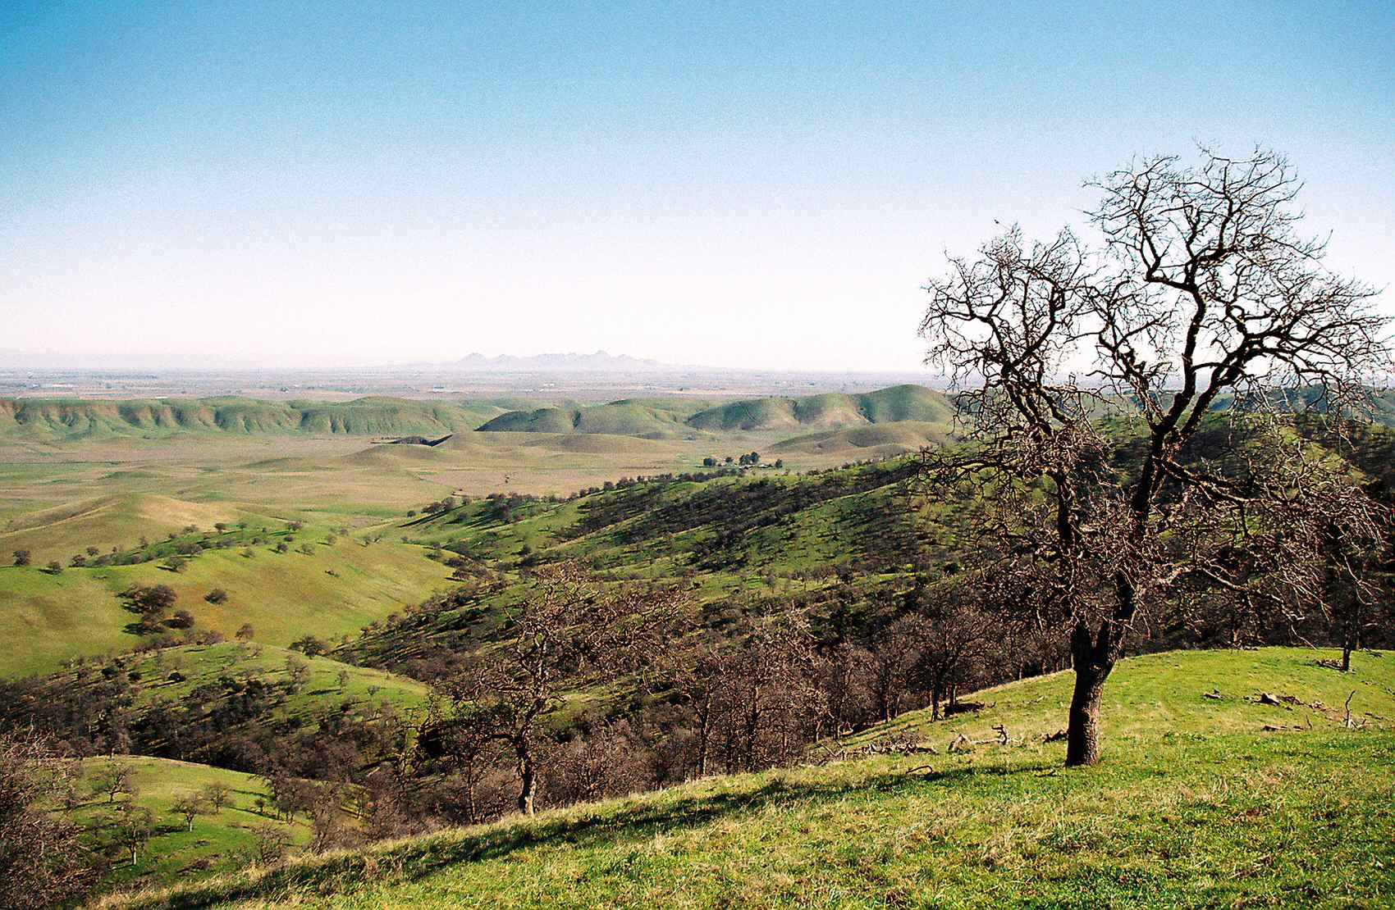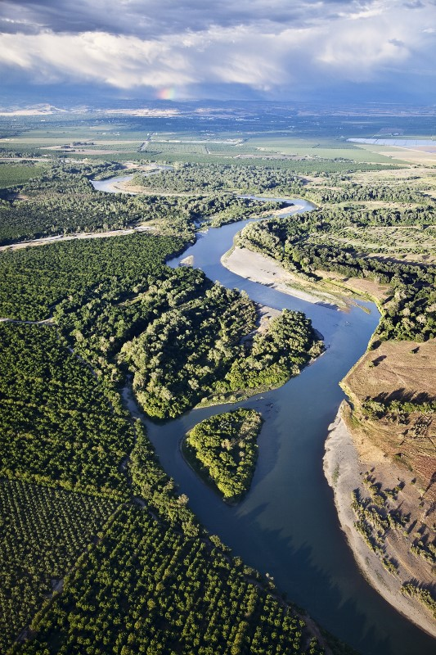
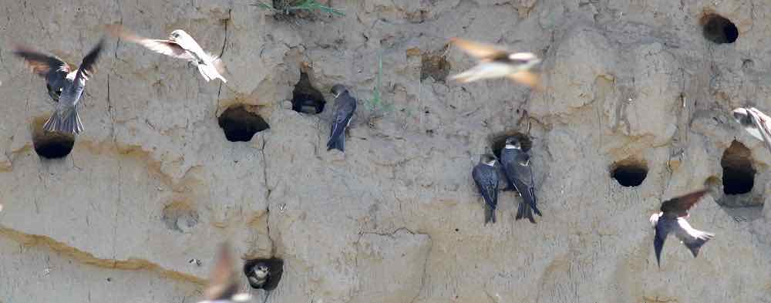
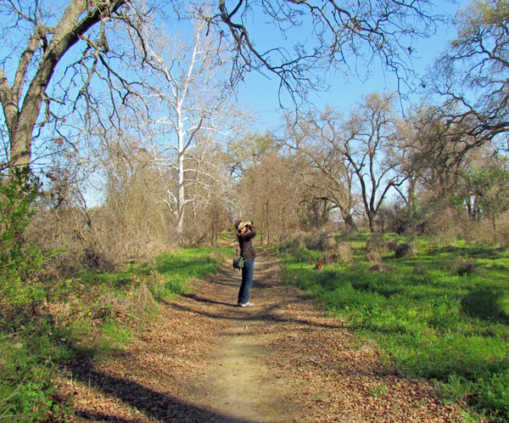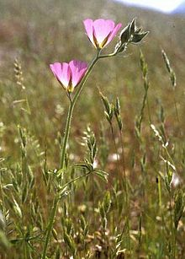

Top to Bottom-Left to Right: More than 14,000 acres of the beautiful Antelope Valley would drown under the Sites Reservoir. Diversions to fill the Sites Reservoir could harm the river’s flow-maintained riparian and aquatic ecosystems. The ecological health of more than 20,000 acres of public river lands could be affected. Reduced flows could limit threatened bank swallow nesting in the river’s eroded banks. The Sites Reservoir will result in significant unavoidable harm to protected golden eagles and the rare Sidalcea keckii.

For the latest version of this fact sheet and other resources, see: www.friendsoftheriver.org/our-work/rivers-under-threat/sacramento-threat/

The North of Delta Offstream Storage Investigation (NODOS) was a joint project of the California Department of Water Resources (DWR) and the U.S. Bureau of Reclamation (BOR) NODOS Storage Investigation Update Introduction, p. 1-1. The Sites Project Authority is a joint powers authority, formed under California law as a combination of local governments sharing governmental powers. https://www.sitesproject.org/sites-project-authority/. It intends to be owner and operator of the project and thus the California Environmental Quality Act (CEQA) lead for the project EIR. Sites JPA NOP: https://www.sitesproject.org/environmental-review/
http://www.water.ca.gov/storage/northdelta/
The Sites JPA has submitted a concept paper to the California Water Commission to receive $2.2 billion dollars for the purported public benefits of the project. (https://cwc.ca.gov/Documents/2016/WSIP/SitesJPA_SitesReservoir.pdf) The Commission has $2.7 billion dollars made available from the 2014 California Water Bond. This is a general obligation bond financed by the general fund from California taxes (https://cwc.ca.gov/Documents/2015/WSIP_GoalsObjectives_Final.pdf). If the project is federally authorized, federal funds can also be awarded the project for certain public benefits of the project. Shasta Lake Water Resources Investigation (SLWRI) Feasibility Report, pp. 6-9, 6-10 table 6-1). (http://www.usbr.gov/mp/slwri/)
NODOS PADEIR Executive Summary, Table ES. 2.5, pgs. ES-13–14, DWR, Dec. 2013. (http://www.water.ca.gov/storage/northdelta/prelim_admin_draft_eir_index.cfm)
Ibid; FAQ: Sites Reservoir Diversion, DWR March 1, 2015. (http://www.water.ca.gov/storage/northdelta/sitesdiversionfaq.cfm) Diversions into the existing irrigation canals would have to use available capacity not otherwise in use. The Delevan diversion and pipeline would not be so constrained. 6,000 cfs equals 12,000 acre-feet per day. At that rate, it would require 100 days to fill a 1.2 million acre-foot reservoir.
A target yield of 100,000 acre-feet per year is displayed for all alternatives, DWR NODOS Investigation Progress Report Appendix A, Table A3-2, pg. A-39, DWR December 2013, (http://www.water.ca.gov/storage/docs/NODOS%20Project%20Docs/NODOS_Progress_Report_12.26.2013.pdf); Before the Water Bond election, the Sacramento Bee carried an article showing average annual “yield” would be 165,000 acre-feet, an estimate close to DWR’s estimated deliveries to water-supply contractors (see below). http://www.sacbee.com/news/local/article2600260.html; DWR NODOS web page summarizes modeled water-supply and other supply benefits as the following: “Total water supply benefits of NODOS would be up to 500 thousand acre-feet (TAF) per year on average and over 600 TAF per year during dry and critical years” (accessed January 24, 2016), http://www.water.ca.gov/storage/northdelta/#NODOSDocs; Water supply increases to water supply contractors and Level 4 wildlife refuge water deliveries are the following: Alternative A (1.27 million acre-feet reservoir, 213,000 acre-feet per year (187,000 to water-supply contractors) with 132,000 acre-feet per year south of delta, Alternative B (1.81 million acre-feet reservoir), 213,000 acre-feet per year (141,000 to water-supply contractors) with 113,000 acre-feet per year south of delta; Alternative C (1.81 million acre-feet reservoir, 246,000 acre-feet per year (172,000 acre-feet to water-supply contractors) with 113,000 acre-feet per year south of delta. Average annual water quality and endangered species act deliveries plus the above water supply and refuge deliveries are the following: Alternative A - 425,000 acre-feet, Alternative B – 429,000 acre feet, Alternative C – 488,000 acre feet. DWR NODOS PDEI executive summary pg. ES-23, 24, table ES-5 and figure E-8, DWR December 2013. http://www.water.ca.gov/storage/docs/NODOS%20Project%20Docs/NODOS_Prelim_Admin_Draft_EIR/00-ES-Executive_Summary_prelim_admin_draft_Dec2013_w_table.pdf
The U.S.G.S. estimated California water use in 2010 at 42,600,000 acre feet. Maupin, M.A., Kenny, J.F., Hutson, S.S., Lovelace, J.K., Barber, N.L., and Linsey, K.S., 2014, Estimated use of water in the United States in 2010: U.S. Geological Survey Circular 1405, p. 9. http://dx.doi.org/10.3133/cir1405.
NODOS PADEIR table ES-5 and figure E-8, pgs. ES-23, 24.
NODOS PADEIR, Table ES-5, pg. ES-23.
NODOS Investigation Highlights, pg. 9, DWR May 2014. (http://www.water.ca.gov/storage/docs/Highlights/NODOS%20Highlights%20Booklet%2028May14.pdf) As noted above, the JPA has told the California Water Commission that the project cost is $4.4 billion. (https://cwc.ca.gov/Documents/2016/WSIP/SitesJPA_SitesReservoir.pdf)
“Is the era of big dam-building over?” by Bettina Boxall, Los Angeles Times Dec. 27, 2015. (http://www.latimes.com/science/la-me-water-dams-20151227-story.html)
Is Sites Reservoir a savior for the Sacramento Valley – or a Delta tunnels project in disguise?, Ryan Sabalow and Dale Kasler, Sacramento Bee, November 13, 2016, http://www.sacbee.com/news/state/california/water-and-drought/article114201138.html
Sacramento River minimum or required flows are based on navigation requirements and outflow/water-quality requirements in the Delta. With potential new diversions of 6,000 cfs, environmental requirements for the Sacramento River itself should be developed that would constrain diversions into Sites Reservoir. In the absence of such requirements, yield estimates for Sites Reservoir are speculative.
NODOS PADEIR pgs. 6-8 thru 83, Tables 7-75, 6-76, 6-77, 6-78; Sacramento River Flow Impacts – Diversions to Sites Reservoir, table prepared by Friends of the River Dec. 9/31/2014, based on DWR’s FAQ: Sites Reservoir Diversion March 1, 2015.
Shasta Lake Water Resources Investigation Fish & Wildlife Coordination Act Report (SLWRI CAR), pg. 108, USFWS Nov. 2014. http://www.friendsoftheriver.org/our-work/rivers-under-threat/sacramento-threat/, Resources, Comments & Documents, Shasta Dam raise, Agency Comments. This document was later “rescinded to allow higher level review.”
Federal and state regulatory agencies have raised concerns about increasing the storage of winter flows on the Sacramento River that may modify flood flows and adversely impact ecosystems, habitats, and threatened and endangered wildlife and fish species in the river and its flood bypasses. These concerns were raised in response to the Shasta Lake Water Resources Investigation (SLWRI) DEIS/FEIS and include the SLWRI CAR, pgs. xii, 122, 127, 165–166, 178, USFWS Nov. 2014; SLWRI DEIS comments, pg. 4, California Dept. of Fish and Wildlife (CDFW) Aug. 2013; SLWRI DEIS comments, pgs. 2-3, U.S. Environmental Protection Agency (USEPA) Sep. 30, 2013. http://www.friendsoftheriver.org/our-work/rivers-under-threat/sacramento-threat/, Resources, Comments & Documents, Shasta Dam raise, Agency Comments
NODOS PADEIR, Table ES-3, pgs. 9-12, DWR Dec. 2013.
SLWRI DEIS comments, pgs. 2–3, U.S. Environmental Protection Agency (USEPA) Sep. 30, 2013.
Personal communication, Sites Project Authority.
Personal communication, Sites Project Authority.
NODOS PADEIR pg. 6-107, Table 6-105; pg. 6-108, Table 6-107; pgs. 6-41 to 6-42, Table 6-40; pg. 6-93, Tables 6-89; pg. 6-105, Table 6-103; pg. 6-101, Table 6-99; pgs. 6-95 to 6-97, Tables 6-91, 6-92, 6-93, 6-94.
NODOS PADEIR, pg. 6-91, Table 6-87; pg. 6-69, Table 6-63.
DRAFT Narrative Of Evaporation From Lakes & Reservoirs For 1998 Water Year Portfolio, DWR June 27, 2002; analysis and extrapolation by Friends of the River.
NODOS PADEIR, Table 14-19, pg. 14-126; Table 14-24, pg. 14-139.
Ibid, Table ES-3, pg. 20 and pgs. 17–22; pg. ES-15; pg. 14-36; pg. 14-87; pg. 14-90, Table 14-25, pg. 14-14; pg. 14-87 thru 89; pgs. 14-140 thru 142.
Ibid – Table ES-3, pg. 15; pg. 13-82; Table 13-12, pgs. 13-41 thru 42; pg. 13-83; pg. 13-92; pg. 13-106; Table 13-30, pgs. 13-124 thru 128.
Ibid – pg. ES-15; pgs.-18-13 thru 16; pgs. 18-37 thru 46.
NODOS Investigation Highlights, Figure 6, pg. 8, DWR May 2014.
SLWRI CAR, pgs. 144–145, USFWS Nov. 2014.
NODOS PADEIR pg. ES-20, DWR Dec. 2013. The JPA is considering not initially constructing the reservoir with power generation facilities to avoid, delay, or diminish Federal Energy Regulatory Commission licensing requirements and procedures and thus speed required approvals (personal communication with JPA). This would considerably increase operational costs since electricity generation is ordinarily used to partially defray pumping costs.
Personal Communication, Sites Project Authority.
Hydropower’s Biogenic Carbon Footprint, Public Library of Science (PLOS) 1, Sep. 14. 2016, http://dx.doi.org/10.1371/journal.pone.0161947
Sites Compendium of Facts, pg. 8, Friends of the River May 11, 2016, based on “Seismicity possibly induced by Lake Mendocino” by T.R. Toppozada & C.H. Cramer, California Geology Dec. 1978; “on the nature reservoir-induced seismicity” by P. Talwani, Pure and Applied Geophysics 1997; South Carolina Dept. of Natural Resources.

